# FULLNAME: BATCH: FREE HTML5 01.2016 - EMAIL:

# PART I: HTML

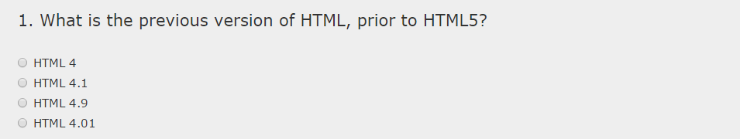

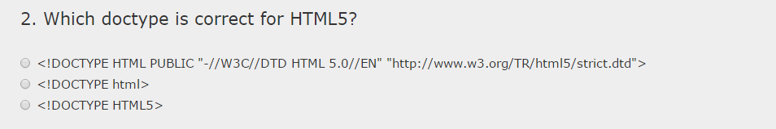

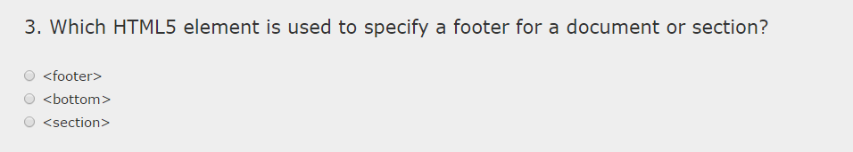

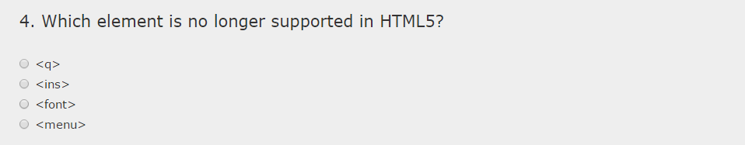

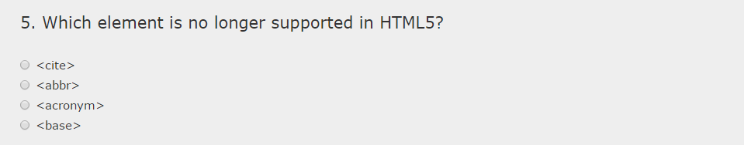

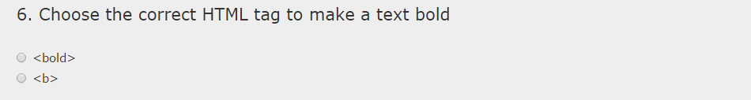

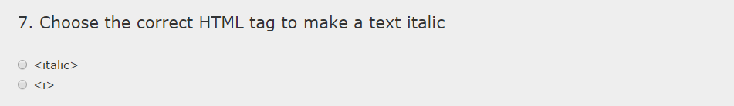

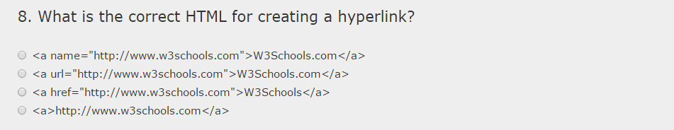

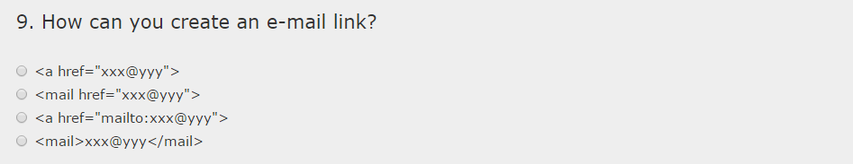

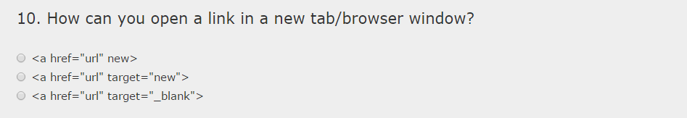

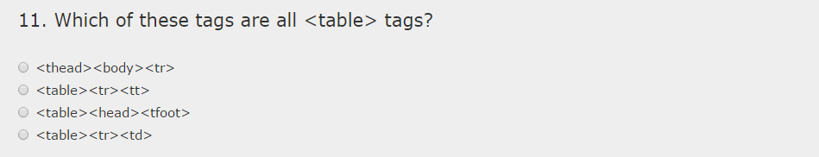

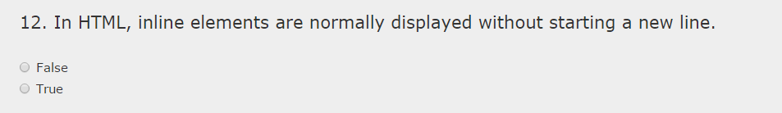

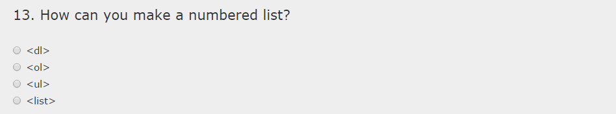

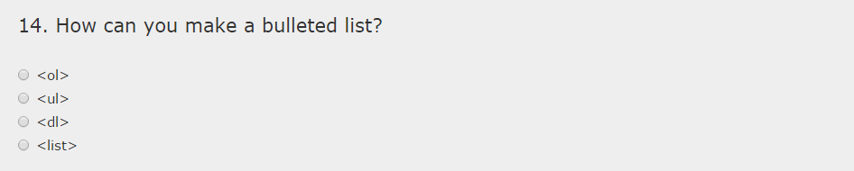

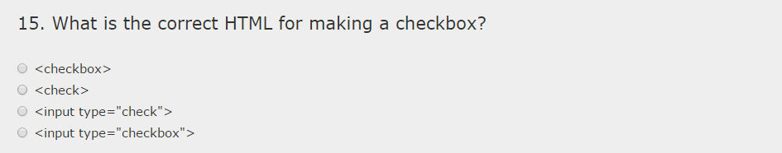

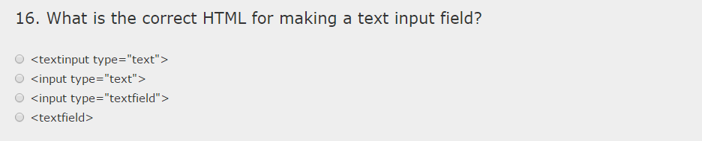

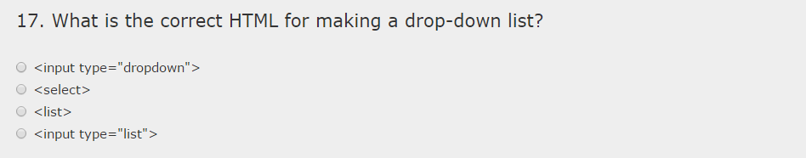

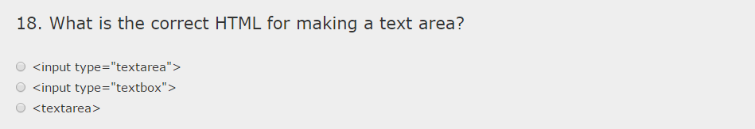

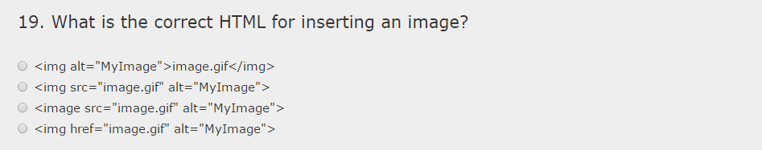

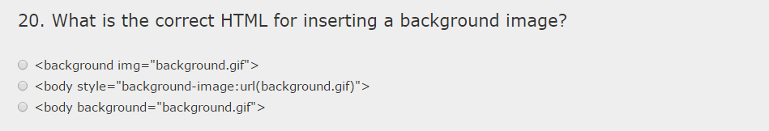

# PART II: JAVASCRIPT

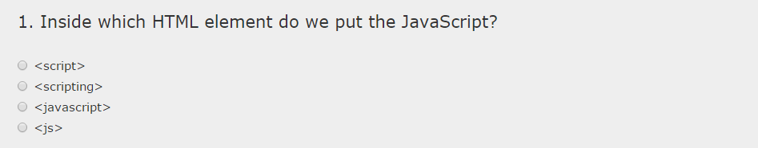

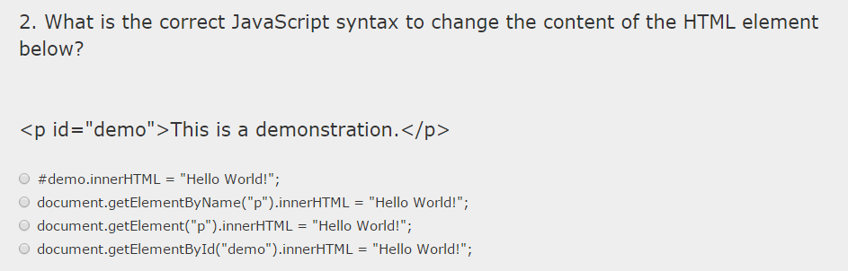

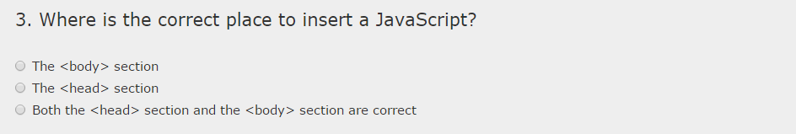

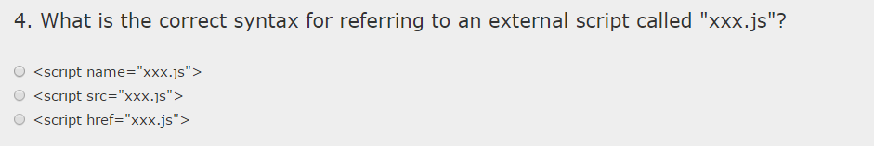

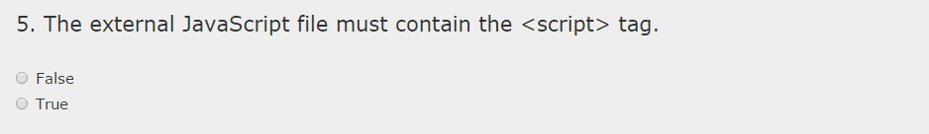

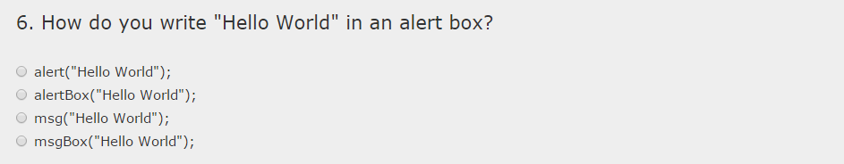

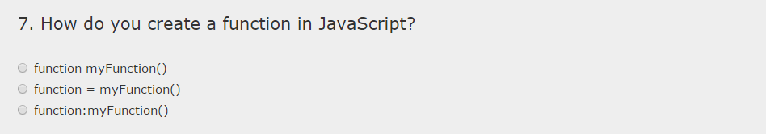

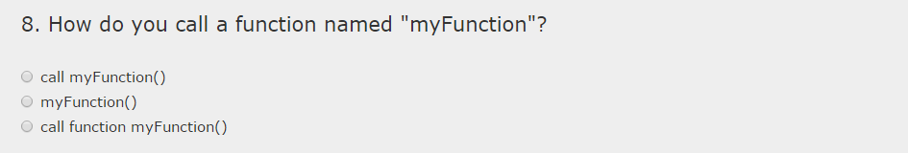

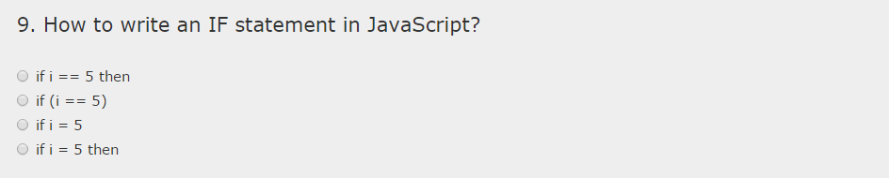

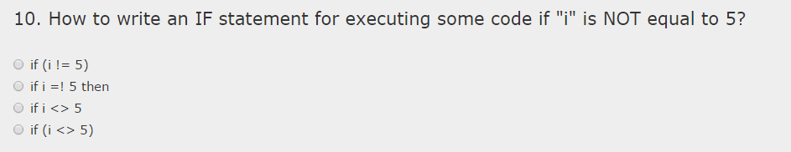

# PART III: CSS

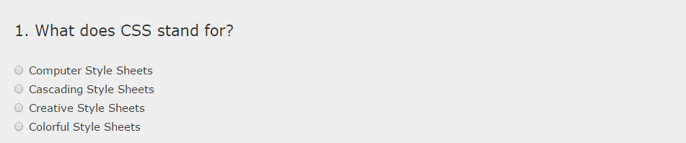

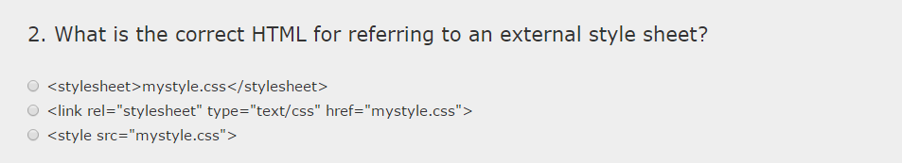

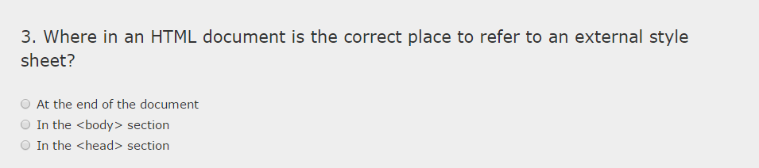

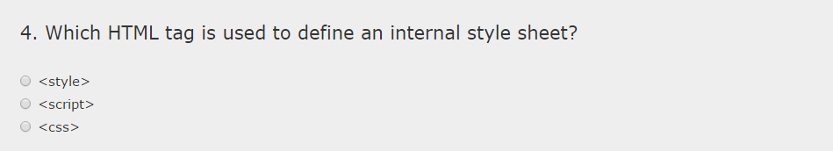

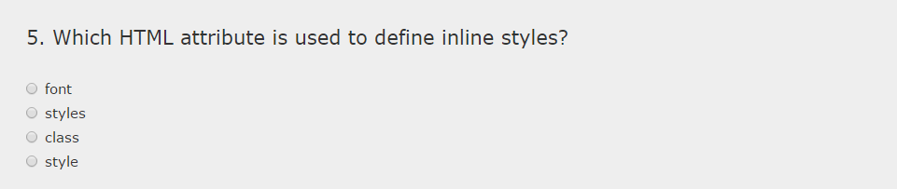

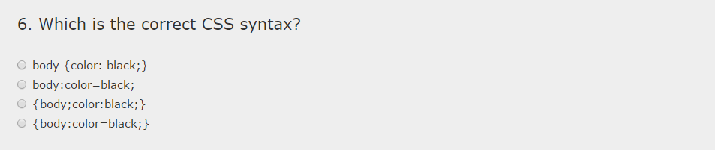

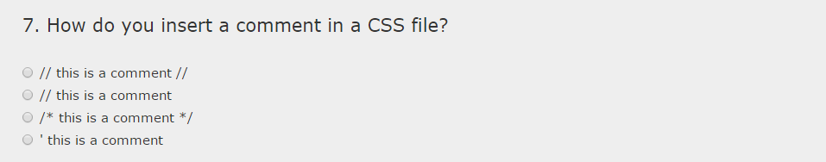

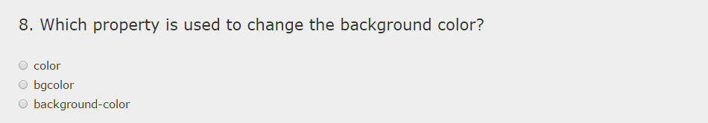

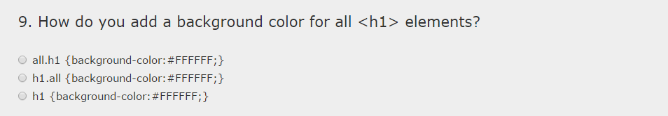

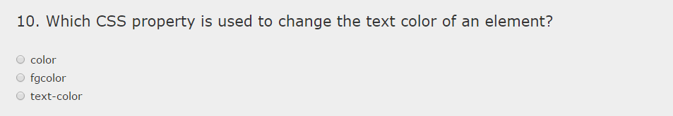

--- END ---